HD 196067

μ2 Oct is a visual binary system. The primary star (HD 196067) is a 1.29 M☉, G1 V star1. The secondary star (HD 196068) is a 1.08 M☉, G1 star. The binary semi-major axis is estimated at 932 au1. Based on 82 RV CORALIE measurements obtained between 1999 and 2012, a study performed in 2013 (hereafter M13)1 reported a LPGP signal around HD 196067 with a period of days, a minimum mass of MJup and an eccentricity of . The CH survey reported a LPGP signal with properties close to those reported in the M13 study.

In the present study, in addition to the M13’s dataset, 19 RV HARPS measurements obtained between 2018 and 2019 were considered. DPASS and MCMC (1000 walkers and 400000 iterations) were used to fit the data. With DPASS, a LPGP with a period of 3508 days, a minimum mass of 6.6 MJup and an eccentricity of 0.6 was found, with a corresponding rms of residuals of 12 m/s. Using MCMC, 2 solutions were found: one was found with a period of days (*a* = 5.0 ± 0.2 au), a minimum mass between 5.8 and 13.5 MJup and an eccentricity between 0.57 and 0.86(case 1), and one was found with a period between 5977 and 8100 days (*a* = 7 – 8.6 au), a minimum mass between 5.7 and 10.1 MJup and an eccentricity between 0.66 and 0.88 (case 2). Hence the period/*a* of HD 196067b is not well constrained.

To explore the range of possible values for the period/*a*, the semi-major axis was fixed to different values and the data fitted with DPASS. *a* up to 8 au (referred to as constrained *a*) do not significantly change the rms of the residuals (13 m/s against 12 m/s with *a* left free). This fit corresponded to the upper limit found using MCMC. The fits are shown in Fig 1, and the corner plots in Fig 2 and 3, and the results summarized in Table 1.

Note that Recently, combining RV and Hipparcos/Gaia absolute astrometry data, a study performed in 20212 were able to estimate the orbital inclination, and thus the true mass, of HD 196067b. They found a period of days, an eccentricity of , an inclination of ° or °, and a mass of MJup.

Conclusion: The properties found in the CH survey for HD 196067b are not confirmed. Additional data are needed to further constrain its orbital properties.

Figure 1: Top left: fit of the HD 196067 RV with DPASS (case 1). Red - C98, green - C07, blue - H03. The blue curve shows the best fit. Top right: fit of the HD 196067 RV with DPASS (case 2). The points are the same as on the left. The blue curve shows the best fit. Bottom left: fit of the HD 196067 RV using MCMC (case 1). The black curve shows the best fit. The colorbar corresponds to the log-likelihood of the fits. Bottom right: fit of the HD 196067 RV using MCMC (case 2). The black curve shows the best fit. The colorbar corresponds to the log-likelihood of the fits. The gray dotted line indicates the end of the CH survey.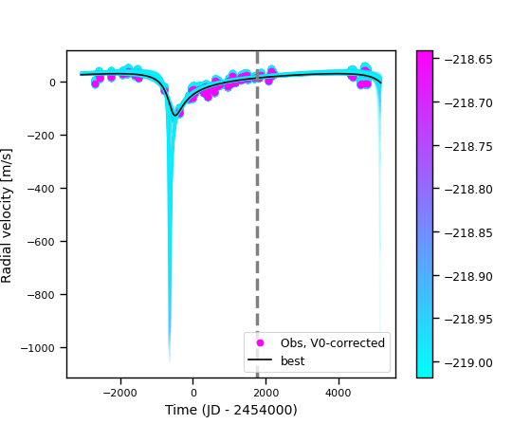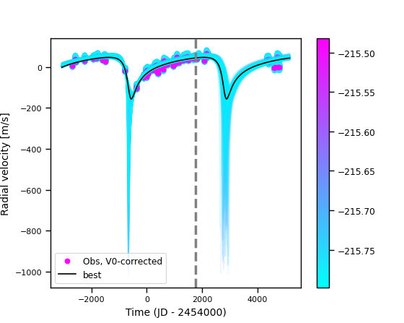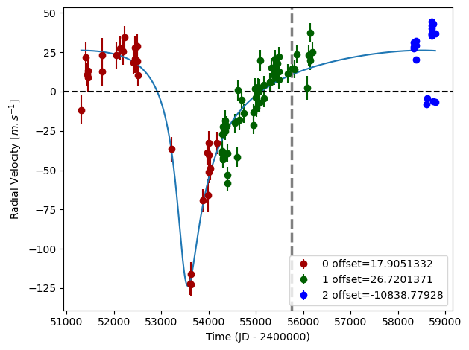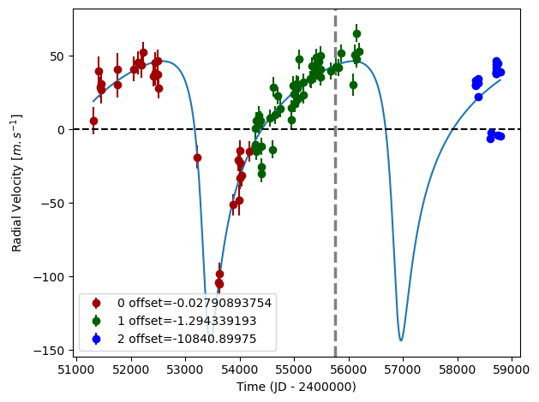

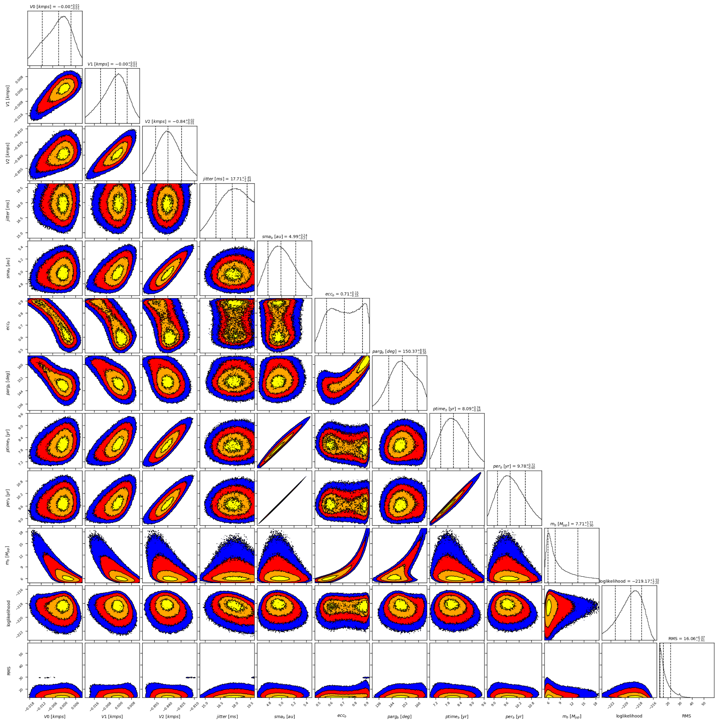

Figure 2: Corner plots of posteriors for the one-planet model MCMC fit of HD 196067 RV data obtained for case 1.

Figure 3: Corner plots of posteriors for the one-planet model MCMC fit of HD 196067 RV data obtained for case 2.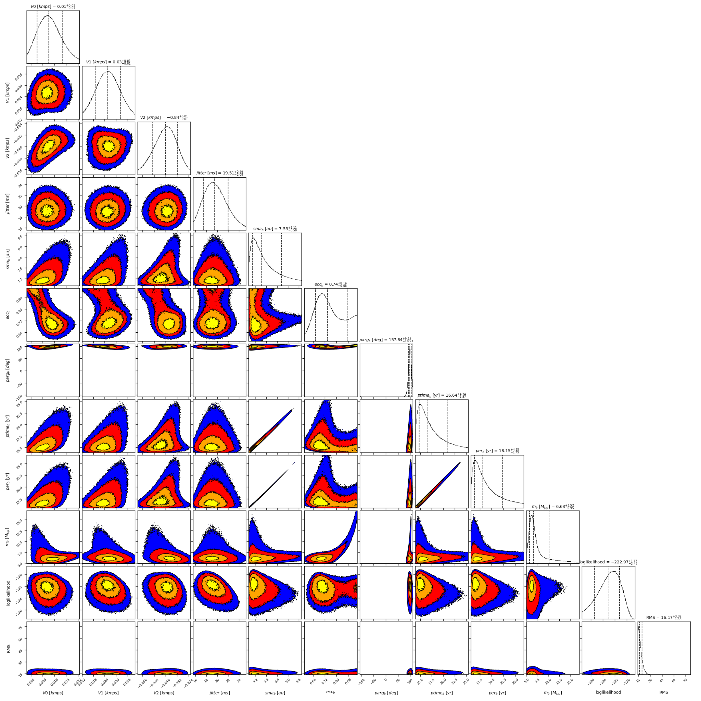

| Parameter | Priors | | | | Posteriors | | | | CH survey |
| --- | --- | --- | --- | --- | --- | --- | --- | --- | --- |
|  | DPASS | | MCMC | | DPASS | | MCMC | |  |
|  | Free priors | Constrained *a* | Case 1 | Case 2 | Free priors | Constrained *a* | Case 1 | Case 2 |  |
| *a* (au) | [4,100] | up to 8 | [4,5.5] | [6,10] | 4.9 | 8 | 5.0 ± 0.2 | 7.0 – 8.6 | 5 |
| Msin(i) (MJup) | [2,100] | [2,100] | [0.5,20] | [0.5,20] | 6.6 | 6.2 | 5.8 – 13.5 | 5.7 – 10.1 | 7.1 |
| Eccentricity | [0,0.95] | [0,0.95] | [0.3,0.95] | [0.3,0.95] | 0.6 | 0.68 | 0.57 – 0.86 | 0.66 – 0.88 | 0.63 |
| Instrumentals offsets (km/s) | [-100,100] | [-100,100] | C98: [-1,1]  C07: [-1,1]  H03: [-11,-9] | [-1,1] | C98: -0.000  C07: -0.001  H03: -10.841 | C98: 0.018  C07: 0.027  H03: -10.839 | C98: -0.003+0.007-0.009  C07: -0.002+0.007-0.010  H03: -10.840 ± 0.014 | C98: 0.012+0.009-0.008  C07: 0.026 ± 0.007  H03: -10.840+0.008-0.009 |  |
| Stellar jitter (m/s) | [0,40] | [0,40] | [0,40] | [0,40] | 16.6 | 17.8 | 17.7 ± 1.5 |  |  |
| Argument of periastron (°) | [0,360] | [0,360] | [0,360] | [0,360] | 146 | 162 |  |  |  |
| Phase | [0,1] | [0,1] | [0,1] | [0,1] | 0.22 | 0.37 |  | 0.92 ± 0.02 |  |

Table 1: HD 196067. Summary of priors and posteriors obtained with DPASS and MCMC, compared to the properties reported by the CH Survey.

References

1. Marmier, M. et al. The CORALIE survey for southern extrasolar planets XVII. New and updated long period and massive planets. *Astron. Astrophys*. 551, A90 (2013).
2. Li, Y. et al. Precise Masses and Orbits for Nine Radial-velocity Exoplanets. Astron. J. 162, 266 (2021).